Phase Locked Oscillator  External Reference |  | MODEL: PmT-3210-Frequency (GHz)
Features:
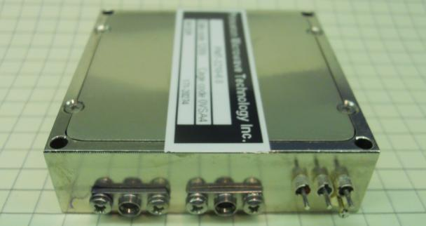

- Small Size
- Excellent Phase Noise
- Low Cost
- Crystal Frequency Stability
- Phase Locked Resonator Oscillator
- SMT Fabrication
- Low Phase Noise
- Packaged Active Devices

Electrical Specifications

Model: PmT-3210-Frequency (GHz)
Parameters | Specifications
Frequency Range | 0.3 to 24 GHz
Power Output | +14 dBm
Load VSWR | 2.0:1
Spurious | -80 dBc
Harmonics | -25 dBc
Alarm | High Z
Phase Noise  10 KHz Offset  100 KHz Offset  1 MHz Offset | 20 Log N + 3 (N=Output Frequency/Reference Frequency  -120 dBc/Hz  140 dBc/Hz
Reference Input Frequency | 100 MHz
Reference Input Power | 0±3 dBm
Frequency Stability | Same as Ext Ref
Voltage | 12/15 V
Current | 250 mA
Package Outline | Figure 101
Connector | SMA-F
Operating Temperature | -25 to 70 °C
Storage Temperature | -55 to 125°C
Size (inches) | 2.25 x 2.25 x 0.62 inches
Finish | Nickel Plated

Package:

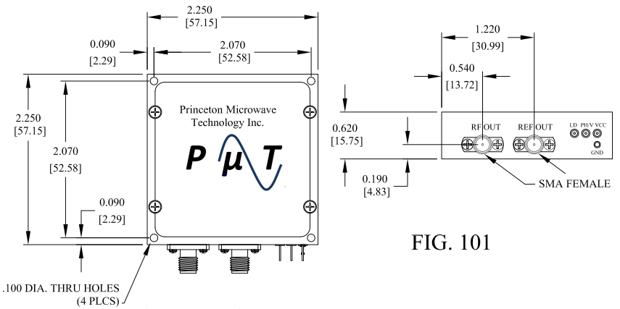

Typical Phase noise plot:

